AFM Data

The column labeled Image00#Ind_Ext is the Indentation depth, d. The software has already computed the difference between the Z-piezo displacement, z, and the cantilever deflection, δ. When plotting the raw data, the X-axis values have already been switched from the “Approach” configuration (curve starting from the right hand side), to the “Indentation” configuration (curve starting from the left hand side):

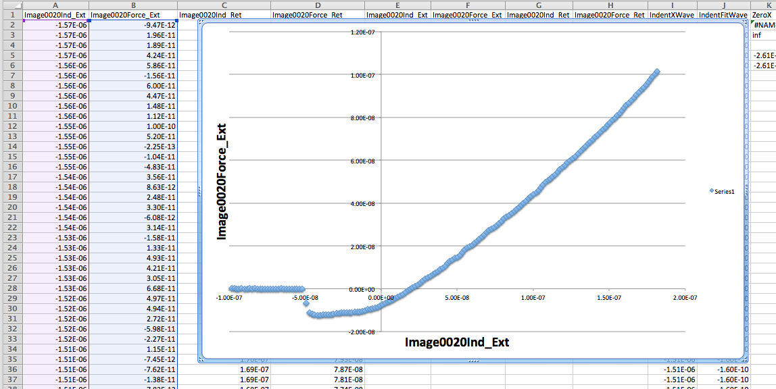

The data does not appear to have been “zeroed” to where the actual indentation of the material begins—after the snap to contact. The cantilever deflection must be “zeroed”:

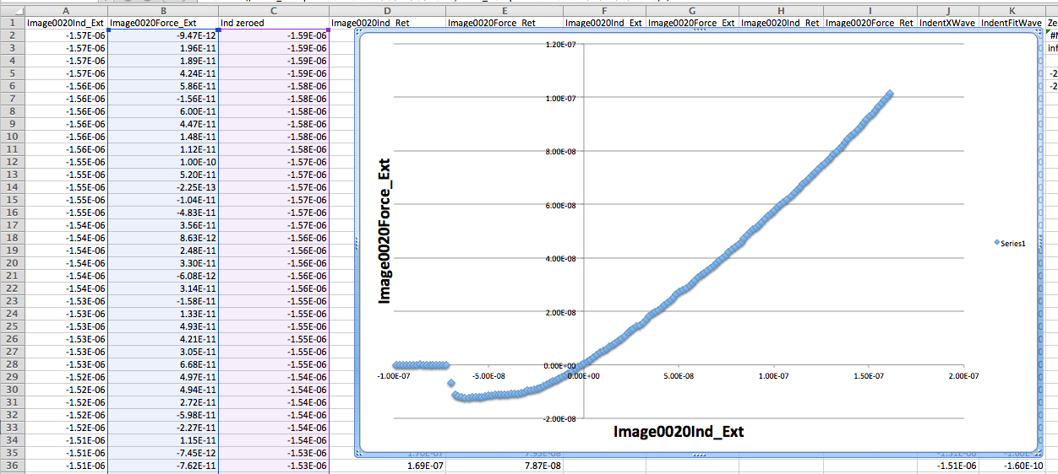

Convert the Image00#Force_Ext from cantilever deflection [m] to force [N] using the cantilever Force constant (spring stiffness). I used a value of k = 1.74 N/m:

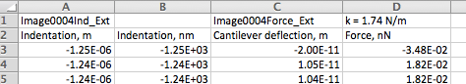

Re-plot the data in Force vs. Indentation and fit with the Hertz model, or others. Here, I’ve just quickly plugged some modulus and radius values in the Hertz contact model for the Fit.

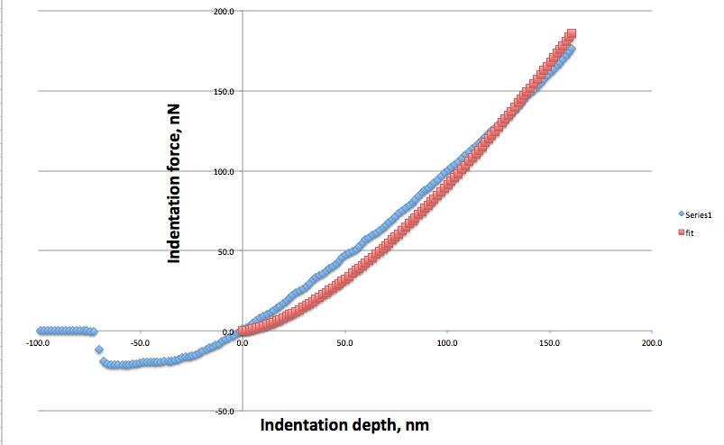

The Sneddon model is another fit you can try. Here is an illustration of the Hertz and Sneddon side by side from http://www.iupui.edu/~bbml/afmintro.html:

